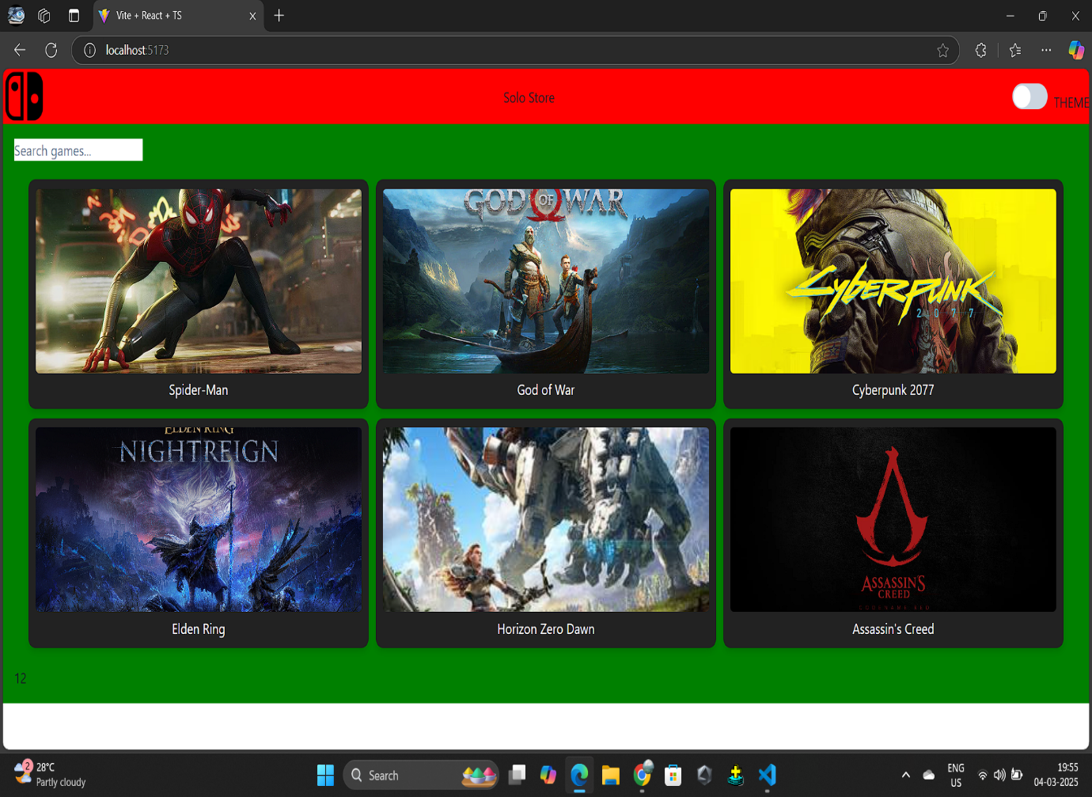

PROJECT NAME: SOLO STORE